**Programming two**

**Project two**

**Team members:**

Ahmed Morsy 4448

Ahmed Ismail 4506

Nevine Said 4500

**Job description**

Ahmed Morsy: XML parsing, problem solving, testing.

Ahmed Ismail: SQL parsing, problem solving.

Nevine Said: Research, UML designer, testing, report.

**Design description**

We have selected the StAX parser for it's event-based streaming, which would allow us to store or obtain data in a procedural fashion. It excels at being memory-friendly for large databases unlike the DOM parser, and has the native ability to write on .XML files unlike the SAX parser. Another reason is that we have tried to work with modern standards, as the StAX parser with .XSD Schema files are simply greater technology than it's other counterparts.

In order to use our DBMS, we have developed a console-like application that takes input from the user and then calls a DBSM. This Console should work with other DBMSs that implement the same interface.

After the Console receives input, the Determiner class decides on which interface function to call. The statement is first validated, then reconstructed in a predefined format in order to prevent the need for precise spacing, and then the operation is determined, necessary data for the operation is extracted and transferred to the QueryHandler.

The QueryHandler is the core of our DBMS, it contains code for each invidiual operation along with an .XSD file writer, an .XML validator using the .XSD for structural integrity, and validation of the .XML file itself. There we perform the required operation on our files.

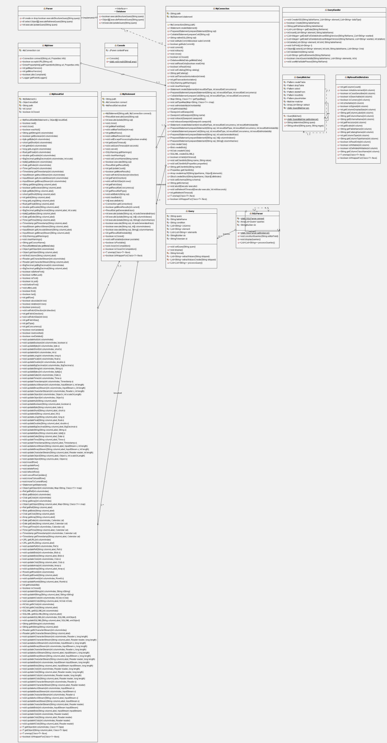UML Diagram